PROJECT DOCUMENTATION

TITLE: GLOBAL ECONOMIC AND DEMOGRAPHIC TRENDS ANALYSIS

NAME: HARTHIKA.S

COURSE: DA-DS (OFFLINE)

BATCH: JUNE 2025

TABLE OF CONTENT

1. | INTRODUCTION
2. | AIM
3. | PROJECT WORKFLOW
4. | DATA DESCRIPTION
5. | TOOLS AND TECHNOLOGIES
6. | DATA CLEANING & TRANSFORMATION
7. | DESCRIPTIVE STATISTICAL ANALYSIS
8. | DAX CALCULATIONS
9. | DASHBOARD CREATION
10. | CONCLUSION

- INTRODUCTION

This project focuses on analyzing global demographic, economic, and health-related data sourced from multiple files, including the CountriesWorld SQL database and three Excel datasets containing population, GDP, and metadata information. The goal is to integrate these datasets in Power BI, clean and transform them using Power Query, and build a unified data model using common fields such as Country Name and Country Code. Through descriptive statistics, DAX calculations, and interactive visualizations, the project aims to identify key trends in population growth, GDP patterns, infant mortality, literacy, and regional development from 1960 to 2017. The final Power BI dashboard presents meaningful insights into global socioeconomic conditions, enabling clear comparisons and data-driven interpretation.

- AIM OF THE PROJECT

To integrate multiple datasets from SQL and Excel into Power BI and build a unified, structured data model using common identifiers such as Country Name and Country Code.
- To clean, transform, and standardize the data using Power Query so it becomes consistent, complete, and suitable for analysis.
- To perform descriptive statistical analysis on key variables such as population, GDP, infant mortality, literacy, birthrate, and deathrate across countries and regions.
- To analyze long-term trends from 1960 to 2017, including population growth, GDP patterns, and changes in health indicators.
- To create meaningful DAX calculations such as GDP per capita, GDP growth rate, and population growth rate for deeper insights.
- To design a comprehensive Power BI dashboard with interactive visuals that highlight global economic, demographic, and developmental trends.
- To derive insights that explain country-level and regional differences in economic strength, population behavior, and health outcomes using the unified dataset.

3. PROJECT WORKFLOW
Data Importing:
Connected multiple data sources into Power BI, including the CountriesWorld SQL database and the three Excel files (PopulationPerCountry, Metadata, GDP 1960–2016).
- Power Query – Data Cleaning:
Used Power Query’s Transform Data to clean and prepare all datasets by removing duplicates, fixing data types, handling missing values, and standardizing categories.
- Data Transformation:
Ensured all tables were structured correctly, standardized column names, and formatted numerical and categorical values for consistency.
- Data Modeling:
Created relationships between datasets using common identifiers such as Country Code and Country Name. Ensured a single, unified data model for analysis.
- Descriptive Statistics:
Performed basic statistical analysis such as averages, minimum, maximum, and standard deviations for population, GDP, literacy, infant mortality, and other key indicators.
- DAX Calculations:
Created calculated columns and measures for GDP per capita, population growth rate, GDP growth rate, regional aggregates, and correlation-based insights.
- Dashboard Creation:
Built a fully interactive Power BI dashboard with bar charts, line charts, maps, area charts, and slicers to visualize global demographic and economic trends from 1960–2017.

4.DATA DESCRIPTION
The project uses four datasets sourced from both SQL and Excel files, each containing different dimensions of global economic, demographic, and health-related information. The CountriesWorld SQL dataset includes key indicators such as country, region, population, area, population density, coastline ratio, net migration, infant mortality, GDP per capita, literacy rate, phone usage, arable land percentage, climate, birthrate, deathrate, and contributions from agriculture, industry, and service sectors. The PopulationPerCountry Excel file contains long-term population data for each country from 1960 to 2017, along with country codes and indicator metadata. The MetaData Excel file provides important categorical information such as income group, region, and country notes linked to each country code. The GDP by Country 1960–2016 Excel file contains historical GDP values for all countries over multiple decades. Together, these datasets provide a comprehensive view of population trends, GDP patterns, income classifications, demographic behavior, and developmental indicators across the world.

5.TOOLS & TECHNOLOGIES
- Power BI
  - Used as the main platform for data connection, modeling, DAX calculations, and dashboard creation.
  - Supports multi-source integration from SQL and Excel.
- Power Query (Transform Data)
  - Used for data cleaning, shaping, and transformation.
  - Handles missing values, data type corrections, standardization, and merging datasets.
- SQL Server / MySQL
  - Stores the CountriesWorld dataset.
  - Used to extract structured data fields such as GDP, population, literacy, and demographic indicators.
- Microsoft Excel
  - Source for PopulationPerCountry, MetaData, and GDP 1960–2016 files.
  - Provides historical and categorical data needed for trend analysis.
- DAX (Data Analysis Expressions)
  - Used to create calculated measures and columns such as GDP growth rate, population growth rate, and GDP per capita.
- Data Modeling Tools within Power BI
  - Used to create relationships between tables based on Country Name and Country Code.

6.DATA CLEANING & TRANSFORMATION
- Importing Data into Power BI
  - All four datasets (SQL + Excel files) were imported into Power BI.
  - The Transform Data option was used to open the datasets in Power Query Editor.
- Handling Missing Values
  - Blank numerical values (population, GDP, literacy, infant mortality, birthrate, deathrate, etc.) were replaced with 0 to maintain accurate calculations.
  - Blank categorical values (region, income group, country name, indicator names) were replaced with “Unknown” for consistency.
- Removing Duplicate Records
  - Duplicate rows found in any dataset were identified and removed to prevent repeated entries and errors in analysis.
- Correcting Data Types
  - Numerical fields were converted to appropriate types (Whole Number / Decimal Number).
  - Text fields such as country, region, and income group were standardized as Text type.
  - Date-related fields (1960–2017) were validated for proper numeric structure.
- Standardizing Column Names
  - Column names were cleaned and standardized across all datasets to avoid mismatch during merging and relationship creation.
- Merging and Relating Datasets
  - Power Query was used to align fields across datasets.
  - Country Name and Country Code were used as primary keys for merging and mapping.
- Transformation of Population & GDP Data
  - Unpivoted year columns (1960–2017) where needed for trend analysis.
  - Ensured population and GDP figures were stored consistently across decades.
- Creating a Final Clean Table
  - After transformations, a unified model was created to support descriptive statistics, DAX calculations, and dashboard visualizations.

7.DESCRIPTIVE STATISTICAL ANALYSIS
- Descriptive statistics were performed using DAX formulas inside Power BI to understand the distribution and behavior of key global indicators.
- Population Analysis:
  - DAX measures were used to calculate mean, median, minimum, maximum, and standard deviation of population across countries and regions.
  - Growth trends from 1960–2017 were analyzed using DAX-based time-series calculations.
- GDP Analysis:
  - Created DAX measures to compute average GDP per capita by country and region.
  - Identified highest and lowest GDP values using DAX formulas such as MAX(), MIN(), and AVERAGE().
  - Historical GDP trends were examined using year-wise DAX calculations.
- Infant Mortality Analysis:
  - Distribution of infant mortality rates was analyzed using DAX calculations for mean, range, and standard deviation.
  - DAX measures helped identify countries with extremely high or low infant mortality.
- Literacy Rate Statistics:
  - DAX was used to compute average literacy rates across income groups and regions.
  - Comparative statistics helped understand educational development patterns globally.
- Trend Analysis (1960–2017):
  - Year-over-year population and GDP trends were analyzed using DAX functions such as DIVIDE(), CALCULATE(), and EARLIER().
  - Time intelligence calculations were applied where necessary to evaluate long-term economic and demographic changes.
- Correlation Indicators:
  - DAX was used to analyze the relationship between literacy rates, GDP per capita, and infant mortality.
  - Insights were drawn to understand how economic strength influences health and education outcomes.

8.DAX CALCULATIONS
The following DAX formulas were created to perform statistical calculations and generate key insights for the dashboard:
- Average GDP per Capita:
This measure calculates the average GDP per capita for all selected countries using the AVERAGE function applied on the GDP_per_Capita column.
- Median Population:
The MEDIAN function was used to find the median population value across all countries, helping identify the central population tendency.
- Minimum Population:
The MIN function was used to determine the country with the lowest population value in the dataset.
- Top Country by GDP per Capita:
A DAX expression using TOPN and ALLSELECTED was created to identify the country with the highest GDP per capita. CONCATENATEX was used to return the country name as the final output.
- Total Population:
The SUM function was used to calculate the total global population by adding up all population values from the dataset.
These DAX formulas helped generate KPIs, statistical metrics, and dynamic insights for the Power BI dashboard.

9.VISUALIZATIONS CREATED & DASHBOARD ANALYSIS
The Power BI dashboard provides a comprehensive view of global demographic, economic, and health-related patterns using multiple visualizations drawn from SQL and Excel datasets. Each visual is designed to highlight meaningful insights and allow users to interactively explore trends across countries, regions, and income groups.
1. KPI Cards
- The KPIs summarize the core global indicators, including
Total Population, Average GDP per Capita, Median Population, Minimum Population, and Top Country by GDP per Capita.
- These KPIs provide immediate high-level understanding of global performance and demographic scale.
2. Map Visual – Countries and Regions
- The world map visual displays each country along with its associated region and income group.
- This helps identify how countries are distributed globally and compare their economic classifications (High income, Upper middle, Lower middle, Low income).
- Regions with high population density or economic dominance become visually clearer.
3. GDP per Capita Chart
- A bar chart shows GDP per capita across countries, helping identify the strongest economies.
- Countries like Luxembourg and other high-income regions appear with significantly higher GDP values.
- This visualization highlights economic disparity between countries and regions.
4. Population Trend Chart (1960–2017)
- A line or area chart visual displays long-term population growth for different countries.
- It shows the overall upward trend in population globally, with countries like India and China showing the highest growth patterns across several decades.
5. Infant Mortality Analysis
- A separate chart displays infant mortality rates across countries.
- Higher values highlight regions with healthcare challenges, while lower rates reflect stronger health systems and improved living conditions.
6. GDP Trend Visualization (1960–2016)
- A multi-year trend chart illustrates how GDP has progressed over time for various countries.
- This helps identify countries with rapid economic development versus those with stagnant or unstable growth.
7. Correlation Insights – GDP vs Infant Mortality / GDP vs Literacy
- Scatter plots or comparison visuals reveal relationships between GDP and other indicators.
- Higher GDP generally correlates with lower infant mortality and higher literacy, indicating links between economy and social development.
8. Population Distribution by Region
- A bar chart or map view shows how population is distributed across regions.
- Asia shows extremely high population values compared to other regions, while Oceania and Europe appear lower in comparison.
9. Slicers for Interactive Exploration
- Filters such as Region, Income Group, Country, and Year allow users to explore specific segments of the world.
- This makes the dashboard dynamic, customizable, and useful for detailed investigation.
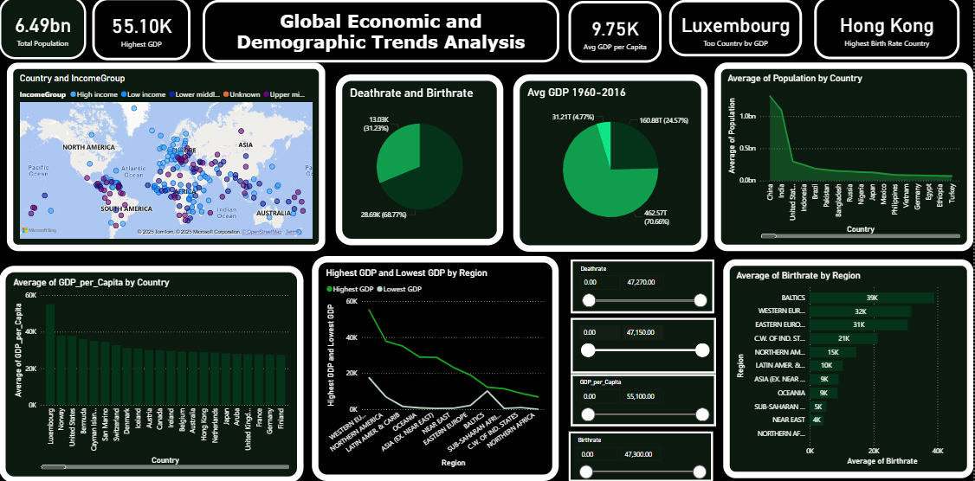

CONCLUSION
This project successfully integrated multiple global datasets from SQL and Excel to develop a unified and fully interactive Power BI dashboard. Through Power Query, the data was cleaned, transformed, and standardized to ensure accuracy and consistency across all sources. Descriptive statistical analysis and DAX calculations were applied to understand key global indicators such as population, GDP, literacy, birthrate, deathrate, and infant mortality. The visualizations created in Power BI provided clear insights into long-term trends, regional differences, economic disparities, and health-related patterns from 1960 to 2017. The dashboard effectively highlights relationships between economic strength, educational development, and demographic behavior across countries. Overall, this project demonstrates strong analytical skills in data modeling, transformation, visualization, and insight generation, offering a comprehensive understanding of global socioeconomic trends.

